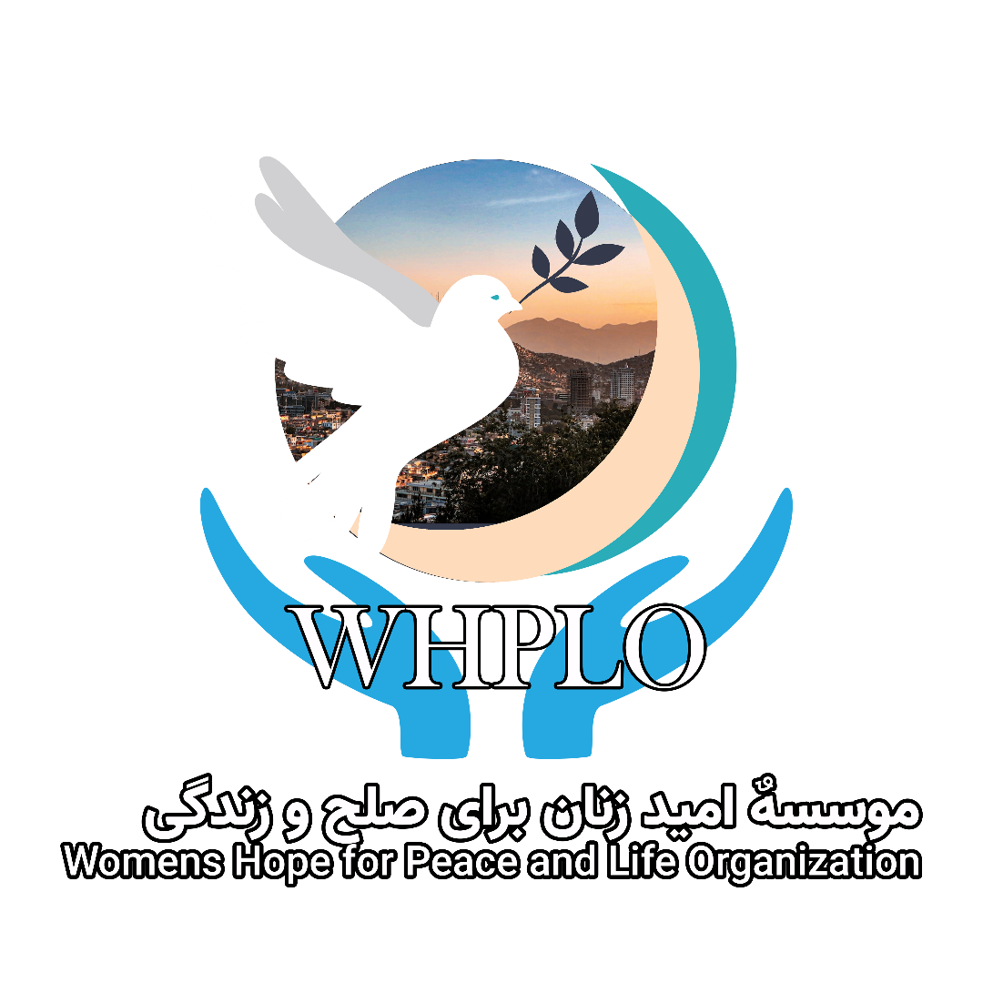

**PROCUREMENT POLICY**

"Corruption and inefficiency in procurement decreases the benefits that public resources otherwise could have delivered to citizens, and also lowers the level of trust and confidence in governments"

**PROCUREMENT POLICY**

"Procurement policies and procedures should be revisited often to make sure they are still meeting your needs, failure to do so could create problems throughout the organization."

# COMMITMENT

The Women`s Hope for Peace & Life Organization (WHPLO) is firmly committed to the highest ethical standards, to combat nepotism and corruption, and to be transparent in all its procurements, programs, and operations in Afghanistan. WHPLO is committed to be accountable to all internal and external stakeholders, including suppliers, beneficiaries, partners, donors, volunteers, interns, employees, management, officers, and the Board of Directors, and to expect the same ethics, transparency, and accountability in return from our stakeholders.

Public procurement is known to be one of the most corruption-prone areas of governance. Although much of the global anti-corruption focus on procurement is in the public sector, similar procurement risks and concerns exist within the world of civil society and NGOs. With this in mind:

WHPLO management and staff will exercise extra caution in all procurements, and adhere to the following ethical guidelines and principles:

1. Ensure that the funds from our donors are spent wisely, and that the quality and price of goods, works, assets and services is competitive, and that the conduct of suppliers fulfill the highest ethical standards.
2. Prioritize Afghan owned and run companies.
3. Prioritize women owned and run companies.
4. Prioritize companies that can document that they provide equal opportunities for women, members of ethnic, language and religious minorities, and persons with disabilities.
5. Suppliers of goods, works, assets and services shall neither seek nor accept instructions from any authority external to WHPLO, or communicate at any time to any other person, government, or authority external to WHPLO, any information known to them by reason of their association with the WHPLO which has not been made public, except as would be normal and expected in the course of their duties, or through WHPLO’s authorization, nor shall suppliers at any time use such information to private advantage. WHPLO will not knowingly procure goods, works, assets and services from suppliers that:
6. Are owned by senior government power holders and members of parliament
7. Are owned by WHPLO senior management, their families, or close relatives
8. Have offered bribes to WHPLO management and staff
9. Finance or support terror
10. Are engaged in the production, sale, or marketing of weapons
11. Employ children (under the age of 15) and youth (legal restriction on working hours and what kind of work youth between the age of 15 and 18 are allowed to do) as per rules and regulations in the Afghan Labor Law (1999) and international labor conventions (ILO

Conventions no. 138 and no. 182

1. Have poor environmental records

|  |
| --- |
| **Afghan Labor Law (1999)**  **Terms of Recruitment – Article 13**  A person who may be employed as an employee shall:   1. Have completed 18 years of age. 2. Completion of 15 years of age shall be required for employees of light industries 3. Completion of 14 years for trainees.   **Reduction of Work Time – Article 31**  The weekly work hours of Employees are reduced in the following cases: (1) For youths between 15 and [under] 18 year of age- 35 hours per week. |

**ILO Convention on Minimum Age, 1973 (No. 138)** is the effective abolition of child labor which is work that is hazardous to children’s health, safety or morals, work that interferes with compulsory education or for which they are simply too young.

C138 was adopted by the International Labor Organization (ILO) in 1973. It stipulates that States should progressively raise the minimum age to a level consistent with the fullest physical and mental development of young people. It establishes 15 as the minimum age for work in general.

The Recommendation of **ILO Convention No. 146** which accompanies Convention No. 138, stresses that national policies and plans should provide for: poverty alleviation and the promotion of decent jobs for adults, so that parents do not need to resort to child labor; free and compulsory education and provision of vocational training; extension of social security and systems for birth registration; and appropriate facilities for the protection of children, and adolescents who work. To achieve the elimination of child labor, laws setting minimum ages for work should be embedded in such comprehensive policy responses.

|  |
| --- |
| **ILO Worst Forms of Child Labor Convention, 1999 (No. 182)**  **Article 3**  For the purposes of this Convention, the term the worst forms of child labor comprises: (a) all forms of slavery or practices similar to slavery, such as the sale and trafficking of children, debt bondage and serfdom and forced or compulsory labor, including forced or compulsory recruitment of children for use in armed conflict […]  (d) Work which, by its nature or the circumstances in which it is carried out, is likely to harm the health, safety, or morals of children. |

Where donors and partners have specific procurement rules and regulations, WHPLO will follow these.

# WHAT IS PROCUREMENT

Procurement, as it relates to organizations such as the WHPLO, refers to the process of purchasing goods, assets, works, or services. It requires preparation, solicitation, negotiation and strategic selection of goods and services, and payment processing, which usually involves several departments of the organization. Competitive bidding is a part of larger scale procurement processes involving multiple bidders to ensure optimal transparency and reduce corruption vulnerabilities.

# DECENTRALIZED VS. CENTRALIZED PROCUREMENT PROCESSES

The WHPLO Procurement Team is represented in all regions and provinces where WHPLO has offices.

WHPLO is implementing decentralized procurement processes for smaller procurements. Procurements of goods and services in value of up to USD 10,000 can therefore be approved by the Head of the Regional, Provincial, or Project Offices, as long as these are in line with agreed budgets and plans of operations.

For medium sized procurements (in value of between USD 10,000 and USD 50,000), WHPLO implements a decentralized procurement process, however, final approval is made by the Country Director, or the Deputy Director & Director of Support Services.

With larger procurements, over USD 50,000, the procurement process is centralized, and documents must be approved by the Country Director. And, for procurements over the value of USD 200,000 the Country Director will consult with the Secretary General before approval is granted, to ensure the greatest possible transparency.

# THE 8 STEPS OF PROCUREMENTS

**Step 1** Identify goods or services needed

***Step 2*** *Announce a Request Quotations (for larger procurements)*

***Step 2*** *Consider a List of Suppliers (for smaller procurements)*

**Step 3** Form an Ad-Hoc Procurement Team for a comprehensive evaluation of suppliers and bids (for larger procurements)

**Step 4** Negotiate contract terms with selected supplier

**Step 5** Finalize the purchase request

**Step 6** Receive invoice and process payment (upon or after delivery)

**Step 7** Delivery and audit of the order

**Step 8** Maintain accurate record of invoices and the procurement process

To ensure efficiency, cost effectiveness and relevance, procurement processes must be flexible, therefore the Country Director alone (for smaller and medium sized procurements), or in coordination with the Secretary General (for larger procurements), may issue a derogation as following a rigid interpretation of procurement guidelines often leads to increased costs.

The Country Director and the Deputy Director can approve a derogation from the standard procurement process for the different thresholds (for smaller and medium sized procurements), while for divisions on procurements of USD 50,001 and above the Secretary General must be consulted.

"In some contexts, it may be difficult to follow certain good procurement practices. It may, for example, be difficult to obtain three tenders if the number of suppliers is limited. Even if three tenders are obtained, they may be forged or may all be written by the same person."

A particular issue in procurement is whether international competitive tendering standards are the best way of getting cost-effective aid and controlling corruption risks. Formal systems which call for national and international tendering may exclude local expertise and labor.

It is important to keep the procurement process as simple, transparent, and as easy to follow as possible. The more complex the process is, the more costly and time consuming it is, and the more likely it is to be intentionally subverted, not for the sake of personal gain, but more for the purpose of expedience.

# PROCUREMENT THRESHOLDS

* **Direct Purchases (DP) USD 1 to 500**

Smaller procurements must be effective and efficient, focusing on quality and cost effectiveness. Purchases should be made based on quality, price and services offered by the supplier. Preference should, if possible, be given to:

* + Businesses owned and/or run by women or provide equal employment opportunities for women
  + Businesses that are owned, run by, or employ persons with disabilities
  + Businesses that are owned by persons in the local community
* **Open Request for Quotation (ORFQ) – Level I USD 501 to USD 5,000** 
  + Procurements through ORFQ should, if possible, be done locally – ideally in the local community (district) or in the same province
  + Purchases should be made based on quality, price and services offered by the supplier
  + Businesses who use child-labor will be disqualified (as defined by the Afghan Labor Law)
  + If the price and quality is comparable, preference should, if possible, be given to:
  + Businesses owned and/or run by women or provide equal employment opportunities for women
  + Businesses that are owned, run by or employ persons with disabilities
  + Businesses that are owned by persons in the local community
  + If frequent procurements are made from the same supplier – Totaling more than USD

10,000 per annum – the supplier must fill in the Vendor Registration Form

* + To prevent jealousy among business owners or service providers, procurements should, if possible, be made from different suppliers. This will reduce suspicion and allegations of nepotism and kickbacks which is especially important in smaller communities. In a multi-ethnic environment it is important that procurements are made from businesses owned by persons representing different ethnic groups (e.g., Ghazni City, Kabul and Maimana) as long as quality, price and service is comparable – This is important in order to contribute to reducing communal, ethnic, and sectarian violence.
* **Open Request for Quotation (ORFQ) – Level II USD 5,001 to USD 10,000**

Procurements through ORFQ should, if possible, be done locally – Primarily in the local community (district) or in the same province

* Suppliers must fill in the WHPLO Vendor Registration Form
* Purchases should be made based on quality, price and services offered by the supplier
* Businesses that use child-labor will be disqualified
* If the price and quality is comparable, preference should, if possible, be given to:
  + Businesses owned and/or run by women or provide equal employment opportunities for women
  + Businesses that are owned, run by, or employ persons with disabilities □ Businesses that are owned by persons in the local community

To prevent jealousy among business owners or service providers, procurements should, if possible, be made from different suppliers. This will reduce suspicion and allegation of nepotism and kickbacks, which is especially important in smaller communities. In a multi-ethnic environment it is important that procurements are made from businesses owned by persons representing different ethnic groups (e.g., Ghazni City, Kabul and Maimana) as long as quality, price and service is comparable – This is important in order to contribute to reducing communal, ethnic, and sectarian violence.

* **Sealed Request for Quotation (SRFQ) USD 10,001 and above**

Procurements through SRFQ should, if possible, be done in Afghanistan – Primarily in the targeted province(s) or elsewhere in Afghanistan

* Suppliers must fill in the WHPLO Vendor Registration Form
* Purchases should be made based on quality, price and services offered by the supplier
* Businesses that use child-labor will be disqualified
* If the price and quality is comparable, preference should, if possible, be given to:
  + Businesses owned and/or run by women or provide equal employment opportunities for women
  + Businesses that are owned, run by, or employ persons with disabilities Afghan owned businesses

# PROCUREMENT TEAMS

For all procurements over the value of USD 500, ad-hoc procurement teams are appointed by senior management. The ad-hoc teams must have competencies and skills related to the goods, assets, works and services to be procured and must be gender balanced and ethnically diverse to reduce corruption vulnerabilities and risks and prevent biases in procurement processes. The composition of the ad-hoc procurement teams will differ based on the value (see Procurement Thresholds above) of the goods, assets, works and services to be procured – Details are outlined in the Handbook.

# EVALUATION OF SUPPLIERS & BIDS

When evaluating a bid, the following will be considered:

* The supplier must fulfill the ethical guidelines and principles of the WHPLO (see above)
* The quality of goods, assets, works and services
* The price competitiveness expertise of technical staff
* The financial strength and stability of the supplier – How long have they been in business?

Are they likely to go out of business any time soon?

* The quality of customer or after sales service
* The ability to meet the timelines of deliveries
* The ability to meet goods or service specifications
* Previous performance with similar orders – Are they consistently on track, or was it a onetime fluke to make a good first impression?